1.INTRODUCTION

1.1 OVERVIEW

**Designing A Logo With Canva**

1.2 PURPOSE

FOR DEPARTMENT DEVOLPMENT

DEVLOP THE CREATIVE THING

2.PROBLEM DEFINATION AND DESIGN THINKING

2.1 EMPATHY MAP 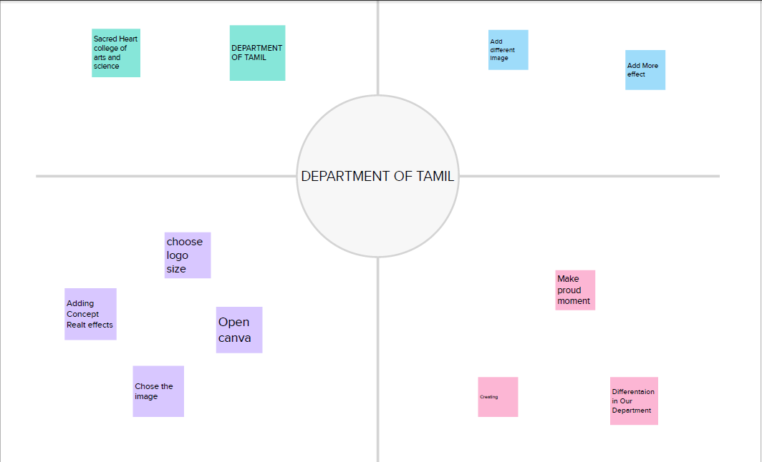

2.2 BRAIN STORM

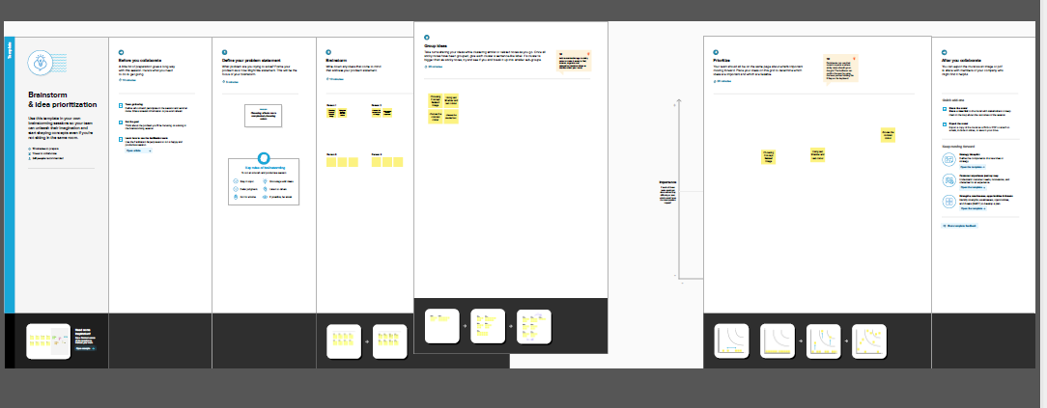

3.Result

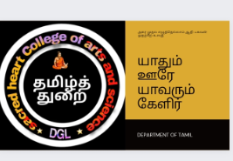

4.ADVANTAGES AND DISADVANTAGES

ADVANTAGES

EASYLE accessible

VERY CREATBLE DISADVAN TAGE

DISADVANTAGES

SOME designs ask money

5.APPLICATIONS

IN FUNCTIONS

FOR ADMISSION PROCES

6.Conclusion

LEARN HOW TO MAKE A LOGO DESIGN.IT IS VERY USEFUL TO DEVLOP CREATIVE THING AND DESIGNING IDEAS